GitHub : https://github.com/mankumarbhalodiya/Digital-Signal-and-Image-Processing
AIM: Simulate dilation, erosion, opening and closing operation on images.
Theory:Dilation, erosion, opening, and closing are morphological operations used in imageprocessing to manipulate the shape and size of objects in an image.
Dilation:Dilation expands the boundaries of objects in an image by adding pixels to the object&#39;sboundaries. It is achieved by sliding a structuring element over the image and assigning themaximum pixel value within the neighborhood of each pixel.
Erosion:Erosion shrinks the boundaries of objects in an image by removing pixels from the object&#39;sboundaries. It is achieved by sliding a structuring element over the image and assigning theminimum pixel value within the neighborhood of each pixel.
Opening:Opening is an erosion operation followed by a dilation operation. It is used to remove noiseand small objects from the image while preserving the larger objects&#39; shapes.
Closing:Closing is a dilation operation followed by an erosion operation. It is used to close small gapsand holes within objects while preserving the overall object shapes.

Code :
import cv2
import numpy as np
from google.colab.patches import cv2_imshow
image = cv2.imread('/content/Certificate 1698299913.jpg', 0)
kernel = np.ones((5, 5), np.uint8)
erosion = cv2.erode(image, kernel, iterations=1)
dilation = cv2.dilate(image, kernel, iterations=1)
opening = cv2.morphologyEx(image, cv2.MORPH_OPEN, kernel)
closing = cv2.morphologyEx(image, cv2.MORPH_CLOSE, kernel)
print("Original Image")
cv2_imshow(image)
print("Erosion")
cv2_imshow(erosion)
print("Dilation")
cv2_imshow(dilation)
print("Opening")
cv2_imshow(opening)
print("Closing")
cv2_imshow(closing)

Output :

Original Image
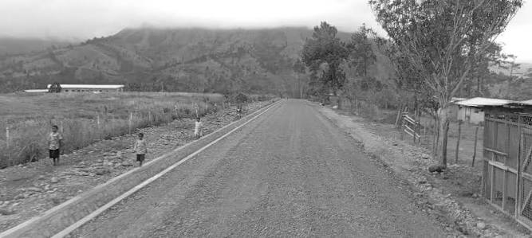
Erosion
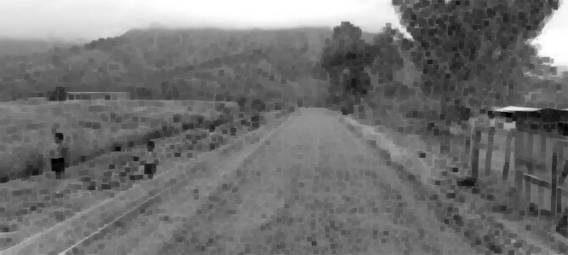

Dilation

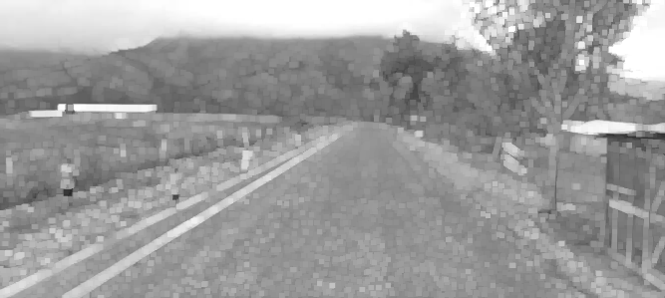

Opening
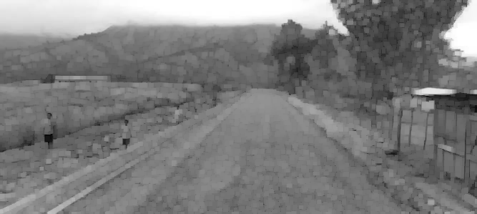

Closing

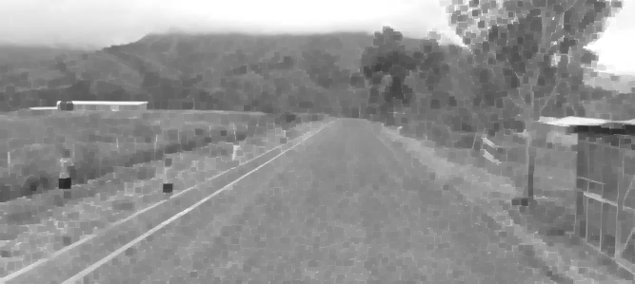

Conclusion: In this experiment, we performed erosion, dilation, opening, and closing operations on a grayscale image using OpenCV. Erosion reduced the white regions, while dilation increased them. Opening helped remove small unwanted objects, and closing filled small gaps in the image. Through this experiment, we understood how morphological operations are useful for image processing and noise removal.

